Dear East Haven Resident,

We hope this letter finds you well. We are writing to inform you about an important update regarding parking regulations in the Beach District of East Haven. The Town of East Haven implemented its Permit Parking Program in 2021. This program was specifically tailored to address the parking issues that were present in the beach area prior to my administration taking office. This requires all residents not residing in the Beach District to log into the online portal at <https://www.tocite.net/easthaven/portal> to create an account and register their vehicle(s). This will allow you to park your vehicle in the designated Beach District areas.

It is crucial to note that even if you have previously made an account and registered your vehicle, you are required to re-register it for the 2024 beach season. This ensures that our records remain accurate and up to date. All previously issued parking permits are now expired.

Enclosed with this letter, you will find informational materials designed to provide you with a comprehensive understanding of the Permit Parking Program. This includes a pamphlet containing Frequently Asked Questions, which we hope will address any initial queries you may have about the registration process and program requirements.

Should you require further clarification or have any additional questions regarding the details of the Permit Parking Program, please do not hesitate to contact my office at (203) 468-3204 or the East Haven Police Department at (203) 468-3820. My dedicated staff will be more than happy to assist you.

Your cooperation and participation in this program are greatly appreciated, as it helps to ensure the efficient and fair allocation of parking spaces in our community. By working together, we can continue to enhance the quality of life for all residents of East Haven.

Thank you for your attention to this matter.

Sincerely,

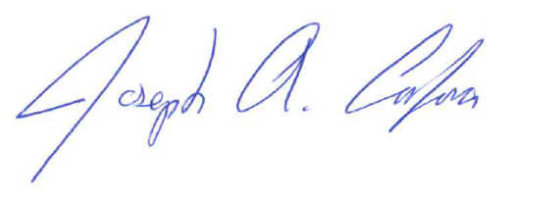

Mayor Joseph A. Carfora