Dear Beach District Resident,

We hope this letter finds you well. We are writing to inform you about an important update regarding parking regulations in the Beach District of East Haven. The Town of East Haven implemented its Permit Parking Program in 2021. This program was specifically tailored to address the parking issues that were present in the beach area prior to my administration taking office. This program requires all Beach District residents to log into the online portal at <https://www.tocite.net/easthaven/portal> to create an account and register their vehicle(s).

It is crucial to note that even if you have previously made an account and registered your vehicle, you are required to re-register it for the 2024 beach season. This ensures that our records remain accurate and up to date. All previously issued parking permits are now expired.

Enclosed with this letter, you will find informational materials designed to provide you with a comprehensive understanding of the Permit Parking Program. Additionally, we have included two guest passes for your convenience, should you have visitors at your residence. Additionally, you have the option to register your guests' vehicles in the permit system.

We encourage you to review the enclosed materials, including the pamphlet of Frequently Asked Questions, which should address any initial queries you may have about the registration process and program requirements.

Should you require further clarification or have any additional questions regarding the details of the Permit Parking Program, please do not hesitate to contact my office at (203) 468-3204 or the East Haven Police Department at (203) 468-3820. My dedicated staff will be more than happy to assist you.

Your cooperation and participation in this program are greatly appreciated, as it helps to ensure the efficient and fair allocation of parking spaces in our community. By working together, we can continue to enhance the quality of life for all residents of East Haven.

Thank you for your attention to this matter.

Sincerely,

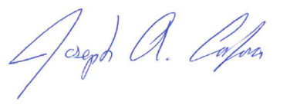

Mayor Joseph A. Carfora